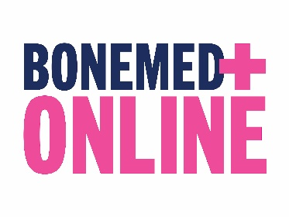
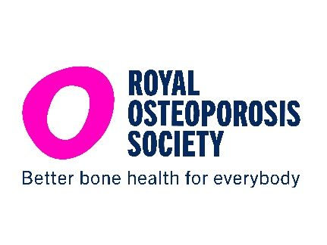

BONEMED ONLINE

PATIENT TEXT, EMAIL AND LETTER TEMPLATES

- Text Message Template (180 characters)

Need support with your osteoporosis medicine? BoneMed Online from the Royal Osteoporosis Society offers free, clear, trusted information. Sign up: https://theros.org.uk/my-bonemed

- Email/letter copy (130 words)

Subject: Free support for your osteoporosis medicine

Dear [Patient Name]

Do you have questions or need support with your osteoporosis medicine?

BoneMed Online is a free, trusted service from the Royal Osteoporosis Society. It provides clear information about your medicine, answers your questions and concerns, and offers practical tips to help you feel confident and stay on track with your treatment between appointments. Thousands of people across the UK are already using BoneMed Online for support with their osteoporosis medicine.

After a 3-minute survey, you’ll receive:

- a medicine summary which includes trusted information and practical tips on what to expect, how to take your medicine, how it works, and possible side effects
- six helpful emails over 12 months to provide extra guidance and ongoing support.

Sign up for free today! Go to theros.org.uk/mybonemed

Kind regards

[Clinician name]

