The FLS Cost Benefit Tool

The ROS FLS Cost Benefit Tool is a separate MS Excel workbook which generates tables and other information that can be used in various stages of establishing or improving a Fracture Liaison Service (FLS). The Tool is not available for download, but trained colleagues at the Charity can use it to run bespoke calculations based on your local data and requirements.
The Tool provides estimates of essential data such as:
- Number of fractures occurring and likely to be prevented
- Potential benefits – cash equivalent and bed days
- Potential costs
- Staff skill mix and whole-time equivalent
- Prescribing costs

This information is formatted as tables, showing the total estimated benefits and costs of implementing and running a service for 1 to 5 years. The Tool already contains data about your organisation and can save you a great deal of time and trouble in research and calculation.

When receiving your cost benefit calculations from the ROS, they will be provided in the form of three PDF documents
- Benefits
- Costs
- Summary

The calculations can be created for NHS Trusts, ICBs and Health Boards.

The initial calculations will have been reached using estimates and assumptions; if needed, the calculations can be altered to better reflect the situation in your health system. Later in the document, when discussing something that can be edited, it will be shown by this statement: [Can be Edited]

Depending on whether there is already an FLS in place, calculations can be produced for two scenarios:
- The costs and provision needed for a fully functioning FLS in your area in total, and the benefits that such a service would deliver
- The costs and provision needed for a fully functioning FLS in your area minus the existing cases being identified, and the additional benefits that such a service would deliver

How the Cost Benefit Tool Works:

Population
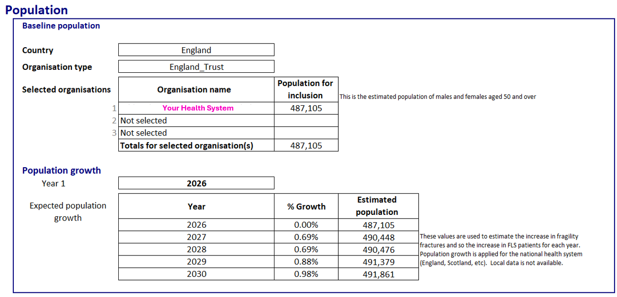
Once your Health system(s) have been selected, it calculates your population for inclusion in FLS (over 50’s). After this, it factors in population growth over the next 5 years.

Identification
Hip fractures are derived from the National Hip Fracture Database. This is used to calculate the total number of fragility fractures is calculated for each year. The Tool is set up to predict 100% of hip fractures being identified and 80% of all other fragility fractures. [Can be Edited]

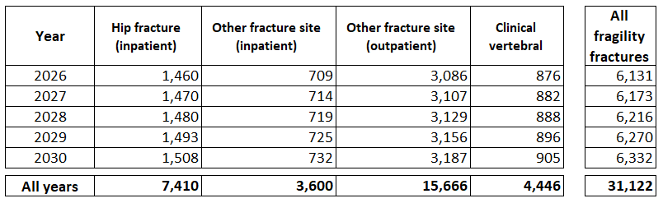

If you have an existing fracture liaison service, the data you submit to the FLS-DB will be automatically uploaded onto the calculator

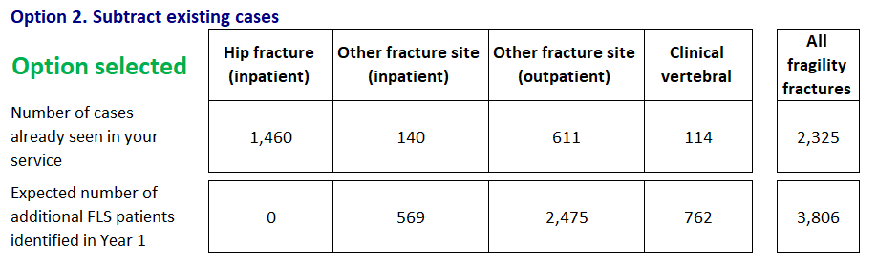

As explained above, the calculations can be provided in two ways. They can show the full cost, provision and benefits of delivering a complete FLS, assuming no service is currently in place. Alternatively, where an FLS already exists, the calculations can take account of the cases already being identified and show the additional provision required, together with the additional benefits that could be achieved.

Prevention
The expected number of fragility fractures prevented is then calculated based on the rate of subsequent fractures, mortality and treatment.

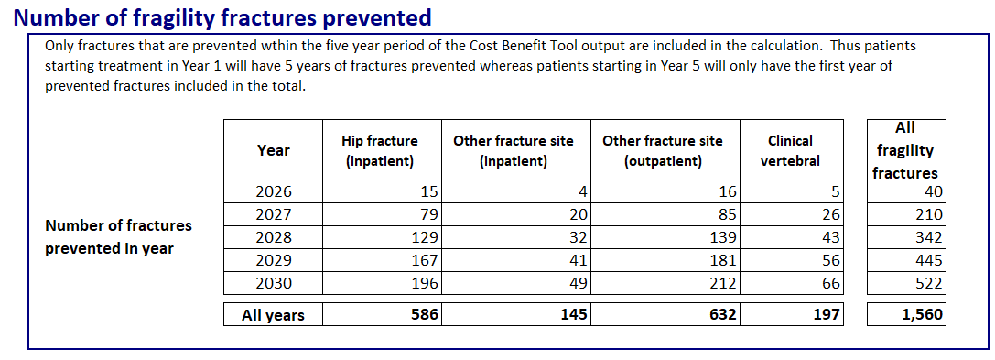

Staffing
The staffing requirement is calculated using estimated time inputs for each stage of the care pathway, along with the grade and type of staff needed to deliver those activities. [Can be Edited]. These costs include High Cost Area Supplements, NHS pension contributions and National Insurance.

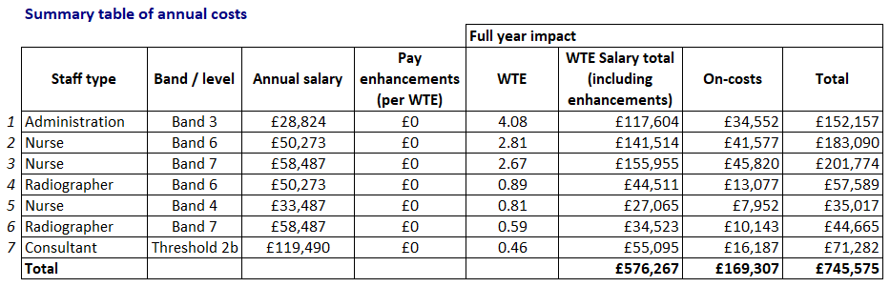

If you are doing this for multiple health care systems or wish to edit this data, this can be done using the FLS Staffing Table shown below. To access this, contact the ROS at FLS@theros.org.uk

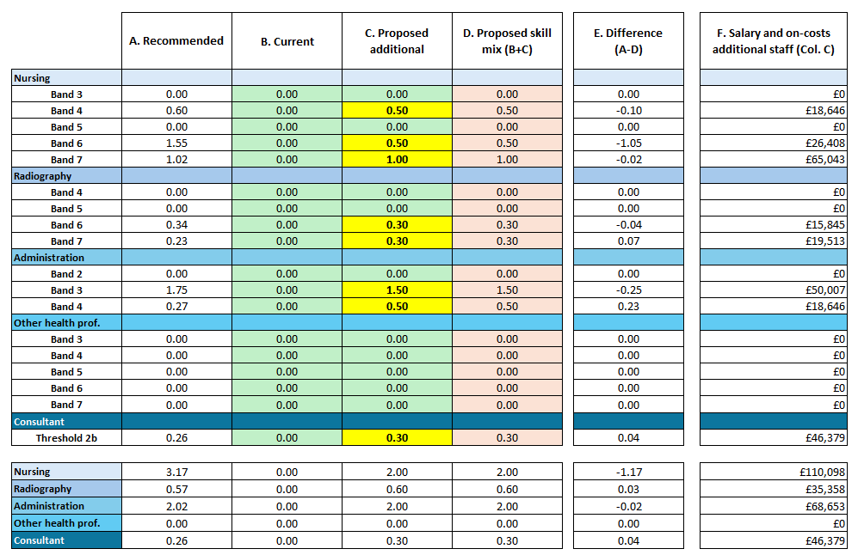

Treatment
There is a range of different treatments designed to reduce the risk of secondary fragility fractures. These treatments vary in efficacy and cost. The number of fractures prevented and the average cost of treatment will depend on the number of patients on each treatment.

Cost of treatment - average per patient - is calculated using best available information about the cost of each treatment to the NHS, taking account of recommended treatment regimens; commercial agreements; different medicinal forms; loss of exclusivity; market prices; and persistence on treatment. Some of these values have been provided to the charity under a non-disclosure agreement; therefore, prices for individual treatments are not available. These values are multiplied by the estimated proportion of patients initiated on each treatment to obtain an average cost of treatment for each patient assessed.

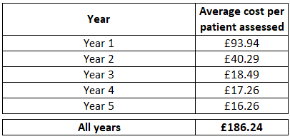

Cost of treatment - all patients (adjusted for date of initiation in Year 1) - Values are further adjusted for the effect of Year 1 for each annual cohort, which is adjusted by 0.5 to reflect that patients will be initiated throughout the year and will therefore not incur a full year cost. Average cost takes account of patient mortality over 5 years from index fracture.
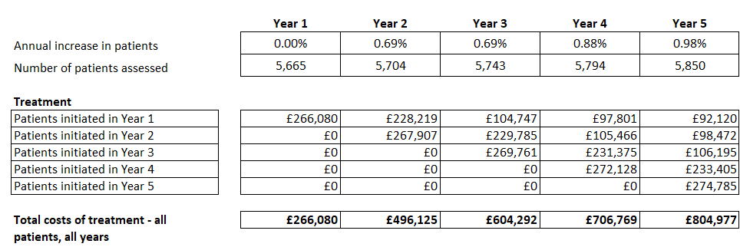

Benefits
The estimated number of fractures prevented is multiplied by the estimated benefits for each fracture prevented. This is calculated for two different types of benefit which are:
Cash equivalent - the estimated costs of health and social care incurred for a fracture of the stated type split into Acute, Community and Primary and Social Care.

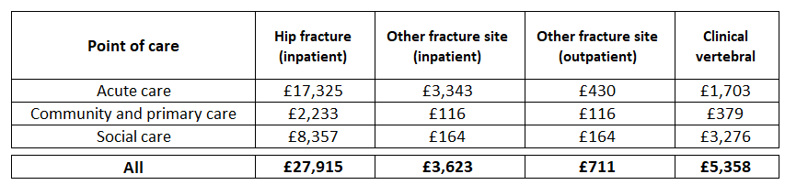

Bed days - the estimated number of bed days incurred for a fracture of the stated type (admitted patients only) split into Acute and Non-acute
The length of stay for each Health System is calculated from the National Hip Fracture Database Outcomes.

